**Problem: 2 readers (Ver 2.0) lose communication in AfiControl**

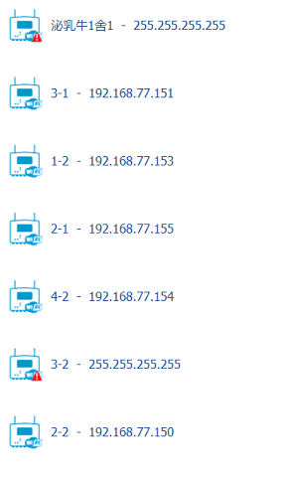

**Checking IP of problem readers and login with** **RSAK2.3.8:**

**show ERROR Message: problem with USB/SD**

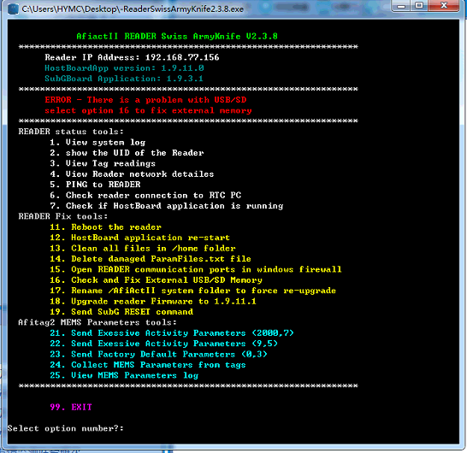

**Type 16 to run the fix tool:**

**Failed by** **operation not permitted**

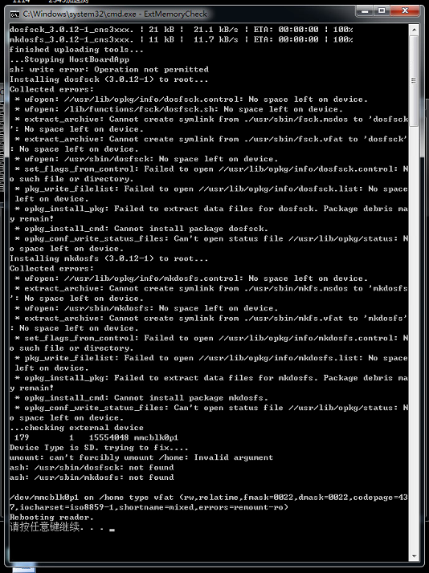

**Also HostBoardApp is not running.**

